AWS Web Application Firewall & AWS Systems Manager

What is AWS WAF?
AWS WAF is a web application firewall that lets you monitor the HTTP and HTTPS requests that are forwarded to your protected web application resources. You can protect the following resource types:
- Amazon CloudFront distribution
- Amazon API Gateway REST API
- Application Load Balancer
- AWS AppSync GraphQL API
- Amazon Cognito user pool
- AWS App Runner service
- AWS Verified Access instance
- AWS Amplify
AWS WAF lets you control access to your content. Based on conditions that you specify, such as the IP addresses that requests originate from or the values of query strings, your protected resource responds to requests either with the requested content, with an HTTP 403 status code (Forbidden), or with a custom response.
At the simplest level, AWS WAF lets you choose one of the following behaviors:
- Allow all requests except the ones that you specify – This is useful when you want Amazon CloudFront, Amazon API Gateway, Application Load Balancer, AWS AppSync, Amazon Cognito, AWS App Runner, or AWS Verified Access to serve content for a public website, but you also want to block requests from attackers.
- Block all requests except the ones that you specify – This is useful when you want to serve content for a restricted website whose users are readily identifiable by properties in web requests, such as the IP addresses that they use to browse to the website.
- Count requests that match your criteria – You can use the Count action to track your web traffic without modifying how you handle it. You can use this for general monitoring and also to test your new web request handling rules. When you want to allow or block requests based on new properties in the web requests, you can first configure AWS WAF to count the requests that match those properties. This lets you confirm your new configuration settings before you switch your rules to allow or block matching requests.
- Run CAPTCHA or challenge checks against requests that match your criteria – You can implement CAPTCHA and silent challenge controls against requests to help reduce bot traffic to your protected resources.
Using AWS WAF has several benefits:
- Additional protection against web attacks using criteria that you specify. You can define criteria using characteristics of web requests such as the following:
  - IP addresses that requests originate from.
  - Country that requests originate from.
  - Values in request headers.
  - Strings that appear in requests, either specific strings or strings that match regular expression (regex) patterns.
  - Length of requests.
  - Presence of SQL code that is likely to be malicious (known as SQL injection).
  - Presence of a script that is likely to be malicious (known as cross-site scripting).
- Rules that can allow, block, or count web requests that meet the specified criteria. Alternatively, rules can block or count web requests that not only meet the specified criteria, but also exceed a specified number of requests in a minute or in five minutes.
- Rules that you can reuse for multiple web applications.
- Managed rule groups from AWS and AWS Marketplace sellers.
- Real-time metrics and sampled web requests.
- Automated administration using the AWS WAF API.
If you want granular control over the protections that you add to your resources, AWS WAF alone might be the right choice.

What is AWS Shield Advanced?
You can use AWS WAF web access control lists (web ACLs) to help minimize the effects of a Distributed Denial of Service (DDoS) attack. For additional protection against DDoS attacks, AWS also provides AWS Shield Standard and AWS Shield Advanced. AWS Shield Standard is automatically included at no extra cost beyond what you already pay for AWS WAF and your other AWS services.
Shield Advanced provides expanded DDoS attack protection for your Amazon EC2 instances, Elastic Load Balancing load balancers, CloudFront distributions, Route 53 hosted zones, and AWS Global Accelerator standard accelerators. Shield Advanced incurs additional charges. Shield Advanced options and features include automatic application layer DDoS mitigation, advanced event visibility, and dedicated support from the Shield Response Team (SRT). If you own high visibility websites or are otherwise prone to frequent DDoS attacks, consider purchasing the additional protections that Shield Advanced provides.

What is AWS Shield network security director?
AWS Shield network security director helps secure your AWS environment by discovering your compute, networking, and network security resources across your account. network security director evaluates each resource's security configuration by analyzing network topology and security configurations against AWS best practices and threat intelligence. To help you strengthen your security, network security director rates its findings from low to critical severity and shares specific remediation steps, which you can explore using natural language queries through Amazon Q Developer.
What is AWS Firewall Manager?
AWS Firewall Manager simplifies your administration and maintenance tasks across multiple accounts and resources for a variety of protections, including AWS WAF, AWS Shield Advanced, Amazon VPC security groups and network ACLs, AWS Network Firewall, and Amazon Route 53 Resolver DNS Firewall. With Firewall Manager, you set up your protections just once and the service automatically applies them across your accounts and resources, even as you add new accounts and resources.

Steps:

Step1: Created two ec2 instances, My-ec2-ALB-01 & My-ec2-ALB-02 with httpd installation in user data
Step 2: Create Target Group
A target group tells the load balancer where to send traffic.
1. Go to EC2 Dashboard
2. Click Target Groups (left panel)
3. Click Create target group
4. Choose:
Target type → Instances
Protocol → HTTP
Port → 80
VPC → same as your EC2 instances
5. Click Next
6. Select both EC2 instances
7. Click Include as pending
8. Click Create target group as TG-ALB
Step 3: Create Application Load Balancer
1. Go to Load Balancers
2. Click Create Load Balancer
3. Choosen as Application Load Balancer
4. Configure:
Name: ALB-01
Scheme: Internet-facing
IP type: IPv4
VPC: same as EC2
Subnets: select at least 2 Availability Zones (important)
5. Security Group: Allow HTTP (80) inbound
6. Listeners as HTTP : 80

Step 4: Attach Target Group
1. In Listeners section
2. Choose Forward to target group
3. Select the target group you created earlier
4. Click Create Load Balancer
Step 5: Verify Health Check
1. Go to Target Groups
2. Open your target group
3. Check Targets tab
Status should show: healthy
If unhealthy:
• Check security group (port 80 open)
• Ensure web server is running on EC2
Step 6: Test Load Balancer
1. Copy DNS name of ALB
2. Paste in browser:
http://<alb-dns-name>
3. Refresh multiple times
Step 7: Configure Web ACL
Select App category as other
Select resources to protect as Add regional resources as ALB-01
Choose initial protection as You build it
Select Custom rule & next
Now select Geo-based rule
Action as Block, rule name as Block-India, statement as India & click Add rule
Step 8: Verify Blocking
Now checked the DNS url of the application load balancer & the request is blocked for India
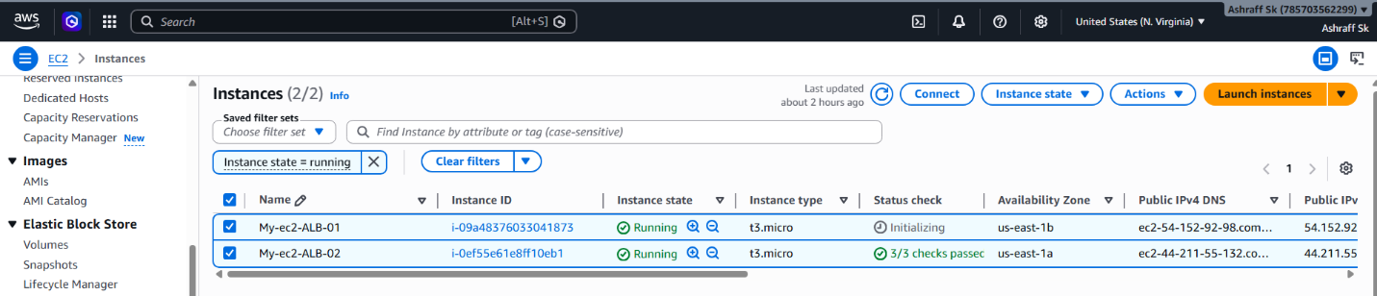
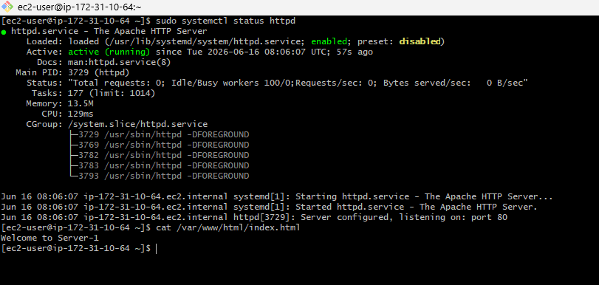
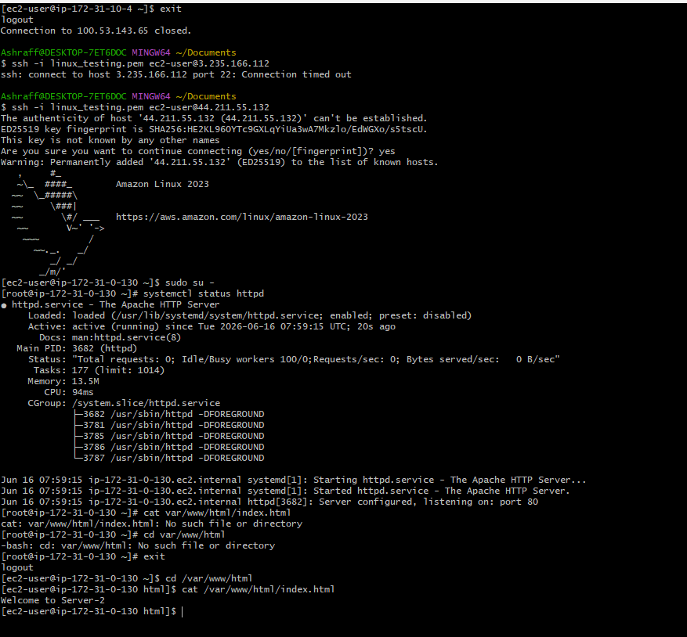
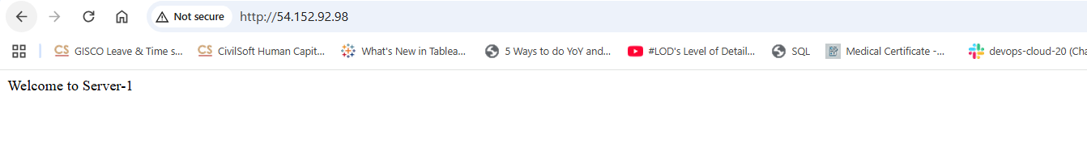
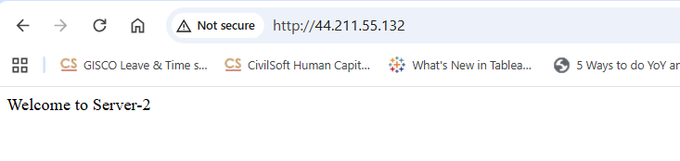
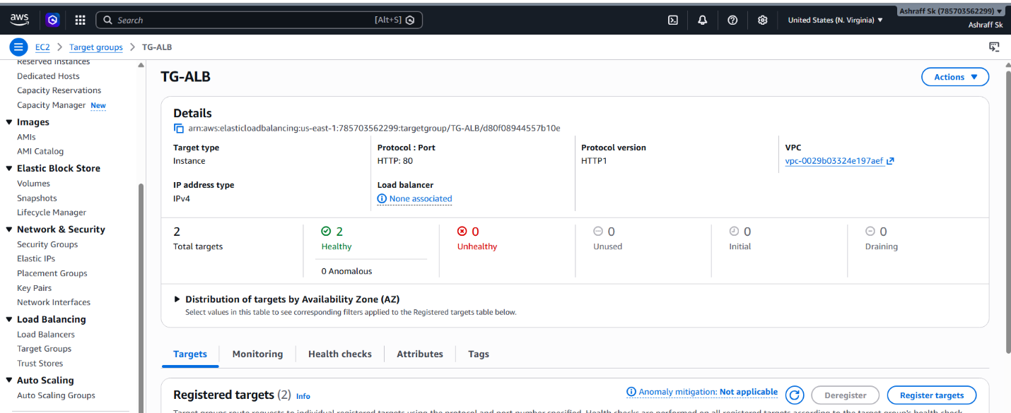
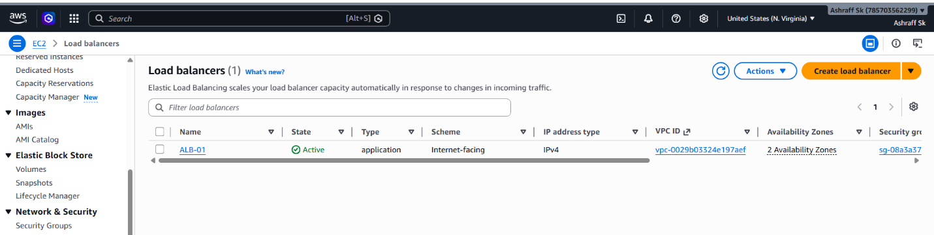
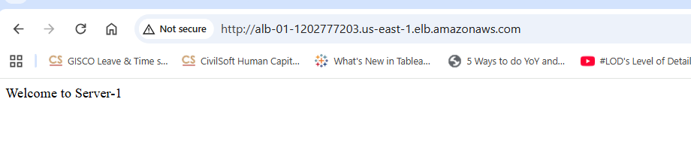
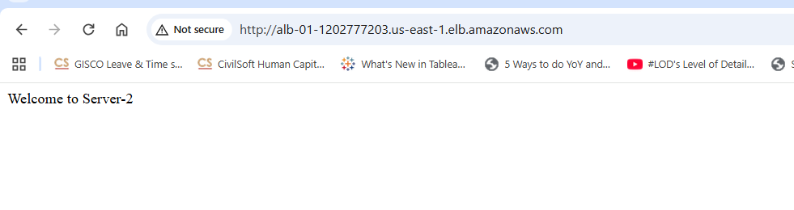
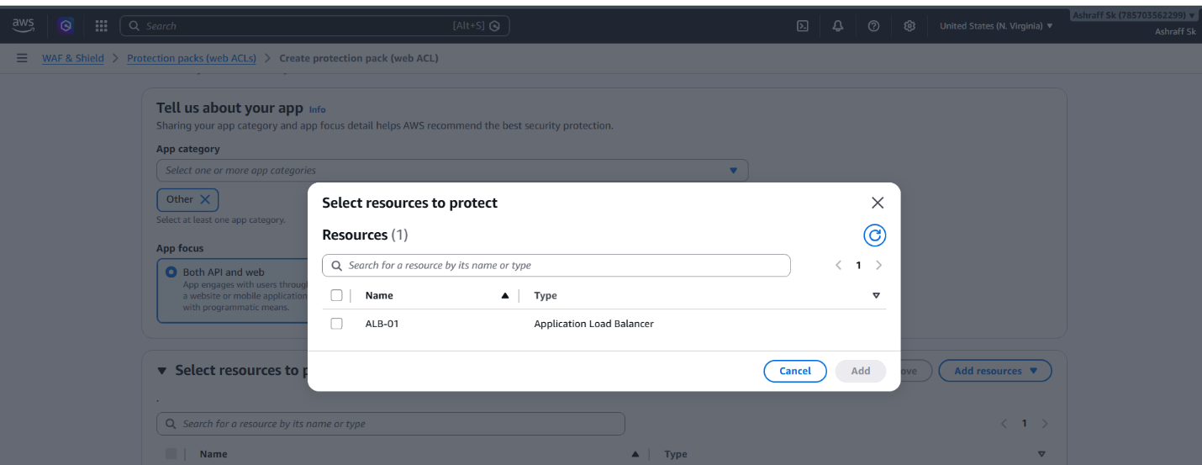

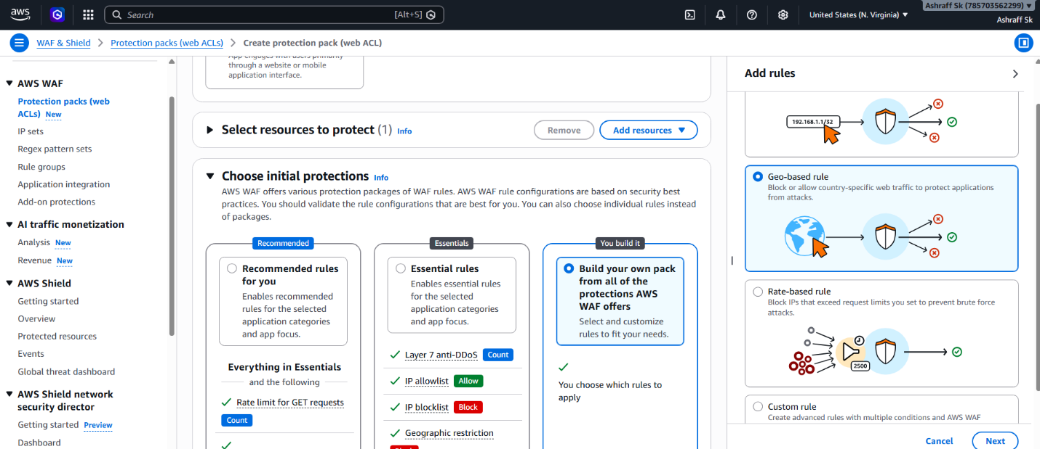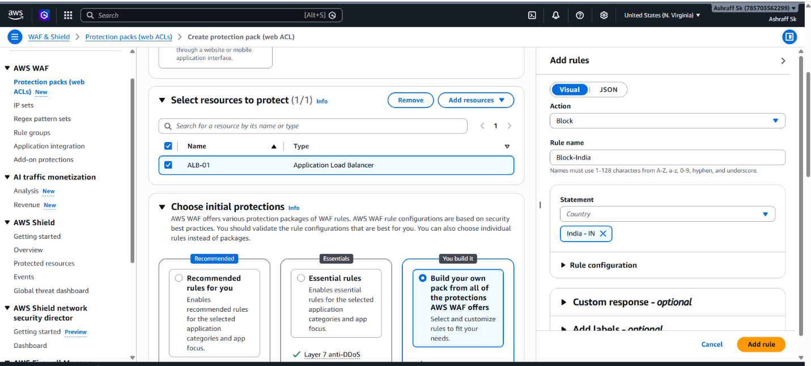
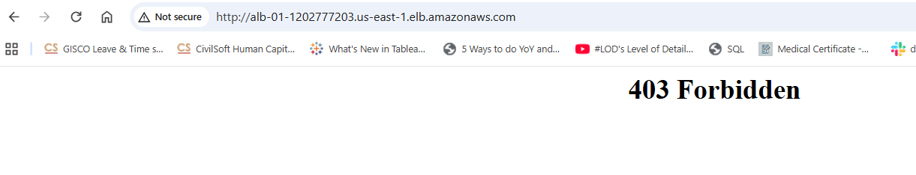

AWS Systems Manager

What is AWS Systems Manager?
AWS Systems Manager is a service that helps you manage, automate, patch, monitor, and securely access AWS resources at scale.
It allows administrators to manage EC2 instances, on-premises servers, and hybrid environments without needing SSH or RDP access.
Benefits:
- No SSH keys required
- No inbound ports required
- Centralized management
- Better security
Core Components of Systems Manager
1. Session Manager
Securely connect to EC2 instances through the AWS Console or CLI.
Administrator
|
v
Session Manager
|
v
EC2 Instance
Benefits:
- No SSH access
- No Bastion Host
- Session logging

2. Run Command
Execute commands remotely on EC2 instances.
Example:
sudo yum update -y
Run on hundreds of servers simultaneously.

3. Patch Manager
Automates OS patching.
Supports:
- Amazon Linux
- Ubuntu
- RHEL
- Windows
Example:
Apply security patches every Sunday

4. Parameter Store
Stores:
- Configuration values
- Database endpoints
- API URLs
- Secure strings
Example:
/db/hostname
/app/environment

5. Automation
Automates operational tasks.
Examples:
- Restart EC2 instances
- Create AMIs
- Stop unused instances

6. Inventory
Collects information about:
- Installed software
- Applications
- OS versions

AWS Systems Manager Run Command – Install
Nginx on Multiple Servers

Launch two instances in AWS EC2 and instances My-ec2-01 & My-ec2-02
After launching we have to add a IAM Role to the instances so that we can connect with SSM manager.
In IAM service, we have to create a new IAM role with the policy AmazonSSMManagedInstanceCore.
And now connect to the EC2 instances and check whether the amazon-ssm-agent is active or not. If not then we have to start the amazon-ssm-agent by using the command -> systemctl start amazon-ssm-agent.
After all these configurations, we have check for the nodes in the systems Manager that our instances are connected with the systems manager service or not.
After verifying the nodes, we have to create a Run Command.
In Run Command, we have to add the SSM document like
AWS-RunShellScript and after this it will ask for the resources i.e.., EC2 instances.
After adding it will ask the for commands execution. We have to give the commands to install and start nginx also to check the status of the nginx.
Now click on run command, it will run the command and also installs the service in the servers attached to that.

